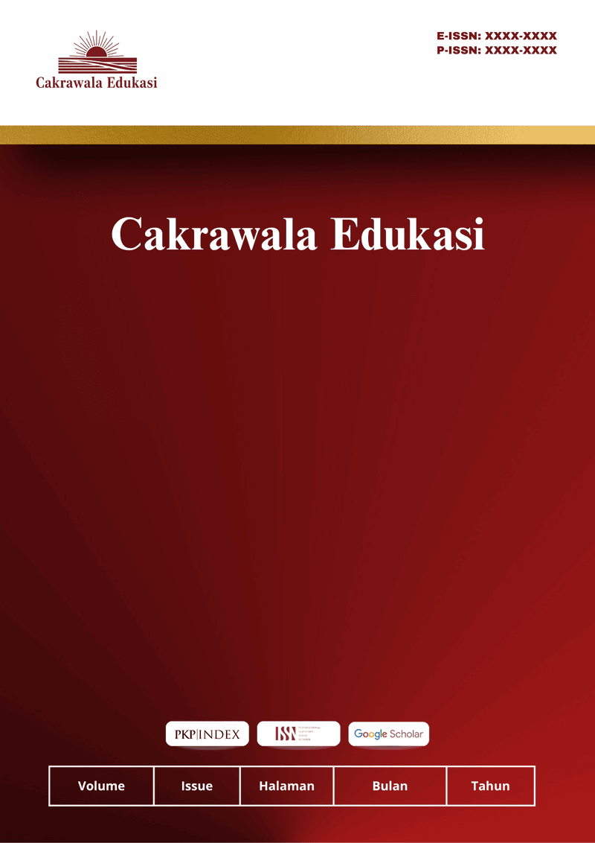
Cakrawala Edukasi
Vol 1 No 1 Agustus 2026
ISSN: XXXX-XXXX (Print) ISSN: XXXX-XXXX (Electronic)
Open Access: https://cakrawalaedukasi.org/cakraedu/index

Developing Comic Strip Based Teaching Materials for Descriptive Text Learning for Grade VII Students at MTs Al-Fikri Bogor

Mohammad Ammaro Zahid^{1*}, Dr. H. Aam Nurjaman, M.Pd.², Stella Talitha, M.Pd.³
^{1,2,3} Universitas Pakuan
email: codddexx@email.com

Article Info :  Received:  DDMMYY  Revised:  DDMMYY  Accepted:  DDMMYY | ABSTRACT
This study aimed to develop comic strip–based teaching materials for descriptive text learning for Grade VII students. The research employed a Research and Development (R&D) method using the ADDIE model, which consists of analysis, design, development, implementation, and evaluation stages. The research subjects were 22 Grade VII students of MTs Al-Fikri Bogor. Data were collected through expert validation sheets, teacher and student response questionnaires, and learning outcome data. The validation results showed that the developed teaching materials were highly feasible, with media experts scoring 90%, language experts scoring 100%, and material experts scoring 97%. The practicality test results indicated that teacher and student responses both reached 93%, categorized as very practical. Furthermore, the learning outcome analysis showed that the product was categorized as very effective in the small-scale trial and effective in the large-scale trial. Based on these findings, it can be concluded that comic strip–based teaching materials are feasible, practical, and effective for supporting descriptive text learning at the junior high school level.

Keywords: Comic strips; Teaching materials; Descriptive text; ADDIE model.
©2022 Authors.. This work is licensed under a Creative Commons Attribution-Non Commercial 4.0 International License.
(https://creativecommons.org/licenses/by-nc/4.0/)
INTRODUCTION
Junior high school students are required to master various text genres, one of which is descriptive text, as part of their literacy competence. However, classroom observations at MTs Al-Fikri Bogor indicated that descriptive text learning was still dominated by textbook-based instruction with limited use of interactive media. Teachers reported that students tended to be passive, had difficulty developing ideas descriptively, and showed low motivation during learning activities. Preliminary learning outcomes also revealed that several students had not yet achieved the minimum mastery criteria, particularly in organizing descriptive details and using appropriate vocabulary.
One contributing factor to this condition is the lack of engaging teaching materials that accommodate students’ visual learning preferences. Conventional materials often fail to stimulate students’ imagination and contextual understanding. Visual-based learning media, such as comic strips, have the potential to address this issue because they integrate images, text, and narratives that can support meaning construction and increase student engagement.
Previous studies have demonstrated that comics can improve motivation, comprehension, and learning outcomes in various subjects. However, most existing research focuses on the implementation or effectiveness of comic media, digital comics, or comics integrated into specific teaching methods. Limited studies have systematically developed comic strip–based teaching materials for descriptive text using a structured instructional design model while simultaneously examining their feasibility, practicality, and effectiveness at the junior high school level.
Therefore, this research positions itself as a developmental study that produces a validated comic strip–based teaching material specifically designed for Grade VII descriptive text learning. The novelty of this study lies in the integration of descriptive text material into a comic strip format developed through the ADDIE model and evaluated comprehensively in terms of feasibility, practicality, and effectiveness. This research contributes both theoretically, by enriching studies on visual-based instructional materials, and practically, by providing teachers with an alternative teaching resource aligned with students’ learning characteristics.

RESEARCH METHODS
This study employed a Research and Development (R&D) approach using the ADDIE model, which consists of five stages: Analyze, Design, Develop, Implement, and Evaluate. The research was conducted at MTs Al-Fikri Bogor involving 22 Grade VII students.
Analyze: At this stage, the researcher conducted classroom observations and informal interviews with teachers to identify learning problems and students’ needs in descriptive text instruction. The analysis revealed that learning materials were limited to textbooks and lacked visual support. Students experienced difficulties in understanding descriptive structures and maintaining learning motivation.
Design:
Based on the needs analysis, the researcher designed a comic strip–based teaching material aligned with the descriptive text curriculum. This stage included determining learning objectives, organizing content, drafting storylines, selecting characters, and designing visual layouts suitable for Grade VII students.
Develop:
The teaching material draft was developed into a complete comic strip product. Expert validation was conducted by three validators: a media expert, a language expert, and a material/content expert. Each expert assessed the product using validation instruments with indicators covering: Media aspects: layout, illustration quality, typography, and visual clarity. Language aspects: readability, grammatical accuracy, and suitability for students’ cognitive level. Material aspects: content accuracy, relevance to curriculum, and learning objectives. Revisions were made based on validator feedback to improve product quality.
Implement:
The revised product was tested through a limited trial involving students. Teacher and student response questionnaires were used to measure practicality, while learning outcome data were used to describe effectiveness.
Evaluate:
Evaluation was conducted continuously at each stage to ensure the product met feasibility, practicality, and effectiveness criteria. Data Analysis: Likert scale scores were converted into percentages and interpreted using predetermined criteria:
81–100% = Very feasible / Very practical / Very effective
61–80% = Feasible / Practical / Effective
41–60% = Fair
≤40% = Not feasible
This categorization provided transparent interpretation of validation and trial results.

RESULTS AND DISCUSSION

Table 1. Expert Validation Results of the Comic Strip Teaching Materials
Expert | Aspect Assessed | Percentage (%) | Category
Media Expert | Media design and graphics | 90% | Very feasible
Language Expert | Readability and linguistic accuracy | 100% | Very feasible
Material Expert | Content relevance and accuracy | 97% | Very feasible

Table 2. Product Practicality Based on Teacher and Student Responses
Respondent | Percentage (%) | Category
Teacher | 93% | Very practical
Students | 93% | Very practical

Table 3. Learning Outcomes from Product Implementation
Trial Group | Average Score | Category
Small-scale Trial | 84.00 | Very effective
Large-scale Trial | 80.38 | Effective
The high feasibility and practicality scores indicate that comic strip–based teaching materials effectively accommodate students’ learning characteristics at the junior high school level. The integration of visual elements, dialogue, and contextual narratives enables students to construct meaning more concretely, particularly in learning descriptive text, which requires detailed visualization of objects, places, and characters. This finding supports visual and multimodal learning theories, which emphasize that learners process information more effectively when verbal explanations are combined with meaningful visuals.
The positive student and teacher responses further suggest that the comic strip format increases learning motivation and classroom engagement. Junior high school students tend to respond positively to story-based and image-supported materials because they reduce cognitive load and make abstract concepts more accessible. By presenting descriptive text structures through visual storytelling, students are better able to identify key elements such as descriptive details, adjective usage, and sensory information.
These findings are consistent with previous studies that highlight the effectiveness of comic-based learning media. Azizul et al. (2020) and Pratiwi et al. (2021) found that comics enhance student engagement and comprehension by presenting learning content in an attractive visual form. Similarly, Hidayat and Subandiyah (2024) reported that comic strip–based teaching materials support language learning by improving students’ understanding and motivation. Compared to these studies, the present research contributes by developing and validating a comic strip–based teaching material specifically for descriptive text learning using a systematic ADDIE development model.
The effectiveness of the developed teaching material was determined descriptively based on student learning outcomes and response data. The “very effective” category in the small-scale trial indicates higher average achievement and more controlled learning conditions, while the “effective” category in the large-scale trial reflects consistent learning improvement across a larger and more diverse group of students. This difference suggests that classroom size and learner variability may influence learning outcomes. It should be noted that this study did not employ inferential statistical analysis; therefore, the effectiveness claim is limited to descriptive interpretation.

Figure 1. Conceptual Framework of the Research
Figure 1 describes the development process of the comic strip–based teaching material using the ADDIE model. The process begins with a needs analysis conducted at MTs Al-Fikri Bogor, revealing that the learning resources used in the classroom were still limited to textbooks and had not been developed into more innovative and engaging media. Therefore, a theoretical review related to descriptive text teaching materials was carried out to determine the appropriate design concept.
Based on the results of the needs analysis and theoretical study, a draft of the teaching material was developed in the form of a comic strip specifically designed for Grade VII descriptive text learning. The draft was then validated by three expert validators focusing on content, language, and media aspects. Revisions were made based on validator feedback to ensure the product’s quality and feasibility.
After revision, the teaching material underwent a limited trial involving a small group of students to evaluate practicality and effectiveness in learning activities. Further improvements were conducted according to the trial results. The process concluded with the finalization of the product after passing a series of feasibility, practicality, and effectiveness evaluations, resulting in a valid and appropriate teaching material to support descriptive text learning

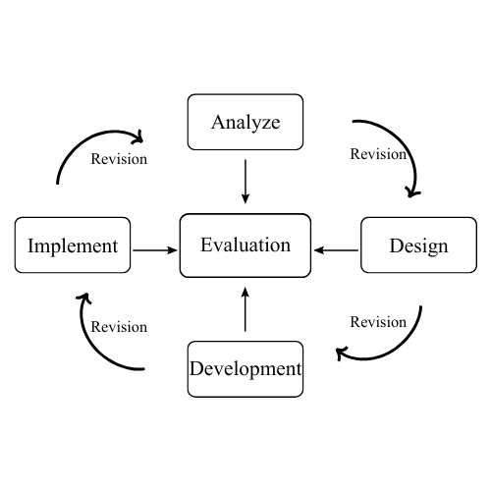

Figure 2. ADDIE Development Model Flow
The figure illustrates the five core stages of the ADDIE model (Analyze, Design, Development, Implementation, and Evaluation), including revision loops that occur when feedback requires improvements at each stage.

Figure 3. Expert Validation Result Chart (Media, Language, Material)
The data in Figure 3 presents the results of expert validation conducted on three key aspects of the developed teaching material: media, language, and content. The media expert provided a score of 90%, indicating that the comic strip layout, visual elements, and technical quality are highly feasible for implementation. The language expert validation resulted in a score of 100%, showing that the language used in the material is clear, communicative, and suitable for Grade VII students. The highest score was obtained in the content validation aspect with 97%, confirming that the accuracy, relevance, and depth of the descriptive text material align very well with curriculum requirements.
Overall, the validation results demonstrate that the comic strip teaching material meets the criteria of very valid and highly suitable to be used as a learning resource in descriptive text instruction.
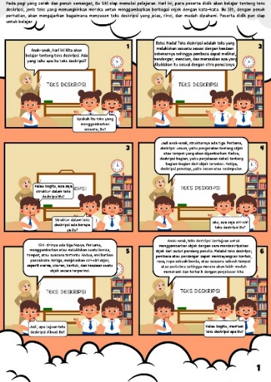

Figure 4. Example of Comic Strip Teaching Material
Figure 4 displays an example of the comic strip teaching material developed for Grade VII students in learning descriptive text. The visual content is designed to present contextual characters and settings that support students’ understanding of descriptive language structures. The storyline, illustrations, and dialogues are constructed to help learners identify key descriptive components such as characteristics, sensory details, and adjective use.
The comic format is intentionally chosen to enhance student engagement through appealing visuals and relatable scenarios. This example also demonstrates the alignment between the learning objectives and the visual material, allowing students to interpret descriptive elements more easily. Therefore, the product serves not only as a reading material but also as a visual literacy resource that encourages active participation and comprehension during the learning process.

CONCLUSION
This research successfully developed comic strip–based teaching materials for descriptive text learning using the ADDIE development model. The results demonstrate that the product is highly feasible, practical, and effective in supporting student engagement and comprehension. Practically, these teaching materials can assist teachers in presenting descriptive text in a more interactive and student-centered manner, particularly for visual learners.
However, this study is limited by its small sample size and the use of descriptive data analysis. Future research is recommended to examine the effectiveness of the product using experimental designs, larger populations, and inferential statistical methods. Further development may also include digital adaptations or application to other text genres.

REFERENCES
Aisyah, S., Noviyanti, E., & Triyanto, T. (2020). Bahan ajar sebagai bagian dalam kajian problematika pembelajaran Bahasa Indonesia. Jurnal Salaka: Jurnal Bahasa, Sastra, dan Budaya Indonesia, 2(1), 1–8.
Adnyana, I. K. S. (2023). Implementasi pembelajaran berdiferensiasi dengan metode picture and picture untuk meningkatkan keterampilan menulis teks deskripsi pada mahasiswa semester III Program Studi PGSD FKIP Universitas Dwijendra. Stilistika: Jurnal Pendidikan Bahasa dan Seni, 12(1), 109–125.
Azizul, A., Riski, W. Y., Fitriyani, D. I., & Sari, I. N. (2020). Pengembangan bahan ajar komik digital pada materi gerak. VOX Edukasi: Jurnal Ilmiah Ilmu Pendidikan, 11(2), 97–104.
Cahyadi, R. A. H. (2019). Pengembangan bahan ajar berbasis ADDIE model. Halaqa: Islamic Education Journal, 3(1), 35–42.
Firmansah, A., Rahmat, R., & Latifah, L. (2023). Pengaruh media komik dalam pembelajaran IPA terhadap penguasaan konsep siswa SMP Negeri 15 Bolo. Jurnal Pendidikan dan Kebudayaan, 3(1), 22–30.
Haqiqi, N., & Permadi, B. A. (2022). Pengaruh penggunaan media komik terhadap hasil belajar peserta didik kelas III tema I subtema I di MI The Noor. Jurnal Riset Madrasah Ibtidaiyah, 2(1), 164–172.
Hidayat, N. I. F., & Subandiyah, H. (2024). Pengembangan bahan ajar menulis puisi berbasis comic strip untuk siswa kelas VIII SMP Plus Gumilar Pacet. Jurnal BAPALA, 11(1), 21–37.
Junaidi, I. N., Sudiana, & Parmiti, D. P. (2023). Pengaruh bahan ajar handout berbasis gambar terhadap kemampuan berpikir kreatif siswa. Pendasi: Jurnal Pendidikan Dasar Indonesia, 7(1), 143–155.
Juliyanti, R., & Suryani, L. (2018). Pembelajaran menulis teks deskripsi dengan menggunakan metode discovery learning pada siswa kelas X. Parole: Jurnal Pendidikan Bahasa dan Sastra Indonesia, 1(6), 977–988.
Laila, R., Sawitri, Y., Marta, Y. M. V., & Yanti, Y. (2019). Pengembangan bahan ajar fisika: Jenis dan karakteristik bahan ajar cetak. Journal of Chemical Information and Modeling, 53(9), 1689–1699.
Magdalena, I., Prabandani, R. O., Rini, E. S., Fitriani, M. A., & Putri, A. A. (2020). Analisis pengembangan bahan ajar. Nusantara: Jurnal Pendidikan dan Ilmu Sosial, 2(2), 180–187.
Marhadi, S. N. L., Agustang, K., Upuolat, H., Alting, N. A., & Hasan, R. (2023). Analisis jenis-jenis bahan ajar dalam proses pembelajaran. Amanah Ilmu: Jurnal Kependidikan Islam, 3(2), 67–74.
Maydiantoro, A. (2021). Model-model penelitian pengembangan (Research and Development). Jurnal Pengembangan Profesi Pendidik Indonesia, 1(1), 12–25.
Mesra, R. (2023). Research & development dalam pendidikan. CV Sinar Cendekia Mandiri.
Mujtahidin, M., & Oktarianto, M. L. (2022). Metode penelitian pendidikan dasar: Kajian perspektif filsafat ilmu. Terampil: Jurnal Pendidikan dan Pembelajaran Dasar, 9(1), 95–106.
Mutiara, E. D., Safitri, D., & Sujarwo. (2024). Pemanfaatan media pembelajaran komik untuk meningkatkan hasil belajar pada mata pelajaran IPS jenjang SMP. Mutiara: Jurnal Ilmiah Multidisiplin Indonesia, 2(2), 43–54.
Nafala, N. M. (2022). Implementasi media komik dalam pembelajaran untuk meningkatkan motivasi belajar siswa. Al-Fikru: Jurnal Pendidikan dan Sains, 3(1), 114–130.
Nilasari, K. E., et al. (2020). Modul pembelajaran Bahasa Indonesia MTs: Unit pembelajaran 3 “Teks Laporan Observasi”. Direktorat GTK Madrasah, Kementerian Agama Republik Indonesia.
Pratama, A., Ratnawati, I., & Rini, D. R. (2023). Penerapan model pembelajaran kooperatif menggunakan aplikasi comic strip untuk meningkatkan minat belajar menggambar komik siswa SMP. Journal of Language, Literature and Arts, 3(3), 323–337.
Pratiwi, P. A., Surjono, H. D., & Suyidno. (2021). Pengembangan buku ajar IPA terpadu SMP berbantuan komik tema “Aku bernapas”. Jurnal Pendidikan dan Pembelajaran Sains Indonesia, 4(1), 58–68.
Pribadi, B. A. (2019). Pengembangan bahan ajar. Prenadamedia Group.
Putra, G. L. A. K., & Yasa, G. P. P. A. (2019). Komik sebagai sarana komunikasi promosi dalam media sosial. Jurnal Nawala Visual, 1(1), 1–8.
Rahmatunnisa, S., Puspitasari, D., & Hidayati, R. (2022). Pembelajaran menulis teks drama menggunakan media flipbook berbasis komik pada peserta didik kelas VIII. Didaktik: Jurnal Ilmiah PGSD STKIP Subang, 8(1), 45–55.
Ramliyana, R. (2019). Penggunaan buku komik “Bahasa Indonesia bagi Penutur Asing (BIPA) 1” dan pengaruhnya terhadap hasil belajar peserta BIPA. Jurnal Bahasa Indonesia Bagi Penutur Asing (JBIPA), 1(1), 30–40.
Rifa’i, A., Asih, N. E. K., & Fatmawati, D. (2022). Penerapan Kurikulum Merdeka pada pembelajaran PAI di sekolah. Jurnal Syntax Admiration, 3(8), 1006–1013.
Rustamana, A., Suandi, M., Rahma, Z. S., & Nugroho, E. (2023). Pengembangan dan pemanfaatan media cetak: Modul, handout, dan LKS dalam pembelajaran. Sindoro: Cendikia Pendidikan, 1(8), 11–20.
Sammi, J. A., & Amir, A. (2023). Implementasi Kurikulum Merdeka pada mata pelajaran Bahasa Indonesia di SMPN 3 Pariaman. Jurnal Pendidikan Tambusai, 7(3), 22916–22927.
Suhada, A., & Nuratikah, R. (2024). Peningkatan keterampilan membaca pemahaman menggunakan metode discovery learning berbantuan media comic strip. Journal on Education, 6(2), 15337–15345.
Turner, D. P. (2020). Teknik purposive sampling. JIIP: Jurnal Ilmiah Ilmu Pendidikan, 6(1), 7–12.
Umar, I. P., Uloli, R., & Jahja, M. (2023). Kepraktisan media pembelajaran berbasis komik pada materi kalor di SMP Negeri 1 Tapa. Jurnal Jendela Pendidikan, 3(1), 83–89.
Walidaini, N. I. M. (2024). Pengembangan media pembelajaran comic strip untuk meningkatkan keterampilan berbicara dalam materi cerita narasi/imajinasi pada siswa kelas VII [Doctoral dissertation, Universitas Bina Bangsa Getsempena].
Wicaksono, A. G., Jumanto, J., & Irmade, O. (2020). Pengembangan media komik komsa materi rangka pada pembelajaran IPA di sekolah dasar. Premiere Educandum, 10(2), 522–537.
Zainab, & Eriga. (2023). Peningkatan hasil belajar siswa melalui media komik materi peluang di kelas VIII.3 SMP Negeri 4 Pemulutan. Indiktika: Jurnal Inovasi Pendidikan Matematika, 5(2), 78–86.

