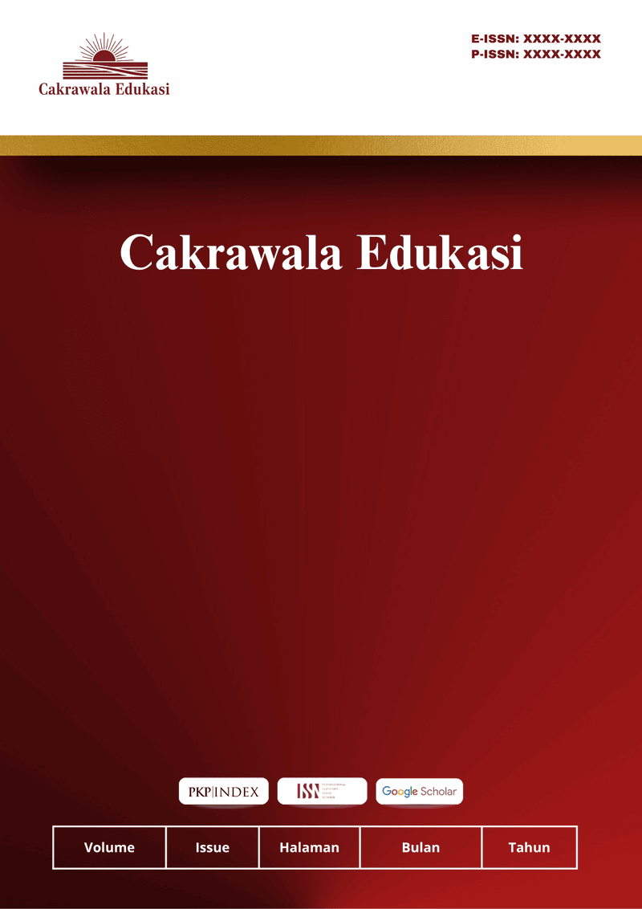
Cakrawala Edukasi
Vol 1 No 1 Agustus 2026
ISSN: XXXX-XXXX (Print) ISSN: XXXX-XXXX (Electronic)
Open Access: https://cakrawalaedukasi.org/cakraedu/index

MEASURING SATISFACTION WITH SCHOOL ADMINISTRATIVE SERVICES BASED ON SERVICE QUALITY THEORY

Mustika Saleha Maulida ^{1*}, Putri Andini ², Tessa Revalina ³, Rifana Rahmalia ⁴, Anisa Nur Azijah ⁵
¹Universitas Muhammadiyah Bogor Raya(9 poin)
email: tikabg432@gmail.com

Article Info :  Received:  DDMMYY  Revised:  DDMMYY  Accepted:  DDMMYY | ABSTRACT (10 PT)
A well-prepared abstract allows readers to quickly and accurately identify the basic content of a document, determine its relevance to their interests, and thereby decide whether to read the document in its entirety. The abstract must be informative and clear enough, written clearly, and provi de a clear statement of the problem, research objectives, research methods, findings, and conclusions. Abstracts should consist of 100 to 200 words. The abstract must be written in the past tense. Standard nomenclature should be used, and abbreviations should be avoided. No literature may be cited. Keyword lists provide the opportunity to add keywords used by indexing and abstracting services in addition to the keywords already present in the title. Wise use of keywords can increase the ease with which interested parties find our articles (9 pt).

Keywords : The first keyword; the second keyword; the third keyword; The fourth keyword; The fifth keywords. (There are a minimum of five keywords and a maximum of six keywords)
©2022 Authors.. This work is licensed under a Creative Commons Attribution-Non Commercial 4.0 International License.
(https://creativecommons.org/licenses/by-nc/4.0/)
INTRODUCTION
In the world of education, the success of an institution is no longer measured solely by academic achievement and the quality of the learning process in the classroom, but also by the quality of the non-academic services provided. One of the supporting pillars that plays a crucial role but often faces challenges on the ground is administrative services. As the primary consumers and key stakeholders in educational institutions, students interact intensively with the school’s administrative service system. Administrative services at schools often serve as the frontline in ensuring students’ comfort throughout their educational journey. From correspondence and tuition payments to managing exam documents, all of these require swift and transparent processes. When school administration runs smoothly, students can focus on their studies without being distracted by complex bureaucratic procedures. Therefore, assessing the extent to which these services meet students’ expectations is crucial. This article aims to measure student satisfaction with school administrative services using the Service Quality (Servqual) theory framework. The results of this assessment are expected to serve as a guide for school administrators in creating an administrative system that is not only internally organized but also student-friendly and convenient for all students.
To objectively assess the quality of this service, the Service Quality (Servqual) theory developed by Parasuraman et al. (1988) serves as a highly appropriate measurement tool because it measures the gap between users’ expectations and their actual perceptions. This measurement involves five main dimensions: tangibles, reliability, responsiveness, assurance, and empathy. Over the past ten years, numerous empirical studies have tested this instrument in an educational context. A study by Ningsih and Erdisna (2025) demonstrated that the quality of administrative services, as measured by Servqual, contributes significantly—accounting for 55.2%—to the variation in student satisfaction at schools. In line with this, an international study published in a Scopus-indexed journal by Farihah et al. (2024), which used the RATER approach (an acronym for the Servqual dimensions), concluded that the dimensions of responsiveness of administrative staff and assurance of administrative services have a significant simultaneous influence on the student satisfaction index. Furthermore, a global literature review covering the past four decades by international researchers confirms that although the Servqual model continues to be widely adopted in various countries, its application consistently gives rise to unique structural variations depending on the characteristics of the institutions where the research is conducted.
Although previous research has extensively addressed service quality using the Servqual method, most international studies (such as those indexed in Scopus) are still dominated by research subjects in the field of higher education or universities. There is a clear gap in the literature, as Servqual evaluations specifically focused on non-academic administrative services at the junior and senior high school levels remain relatively limited. The novelty of this study lies in the contextualization of the five Servqual dimensions within the operations of secondary school administrative units that are currently in a transitional phase from traditional manual administration to a semi-digital system. This research is urgently needed, given that the slow processing of administrative documents and the lack of responsiveness from school staff often lead to a decline in students’ satisfaction and trust in these educational institutions. Through this empirical gap analysis, schools are expected to be able to take targeted tactical steps to continuously improve the quality of administrative services.

RESEARCH METHODS
This study employs a quantitative descriptive design aimed at measuring the level of service user satisfaction with the quality of school administrative services using the Service Quality (Servqual) model. The study was conducted at SMK Muhammadiyah 9 Nanggung, given the dynamic nature of its administrative services and the availability of adequate data access. The population in this study included all active students as the primary users of school administrative services during the current academic year. Based on Roscoe’s theory of sample size, the appropriate sample size for a quantitative descriptive study ranges from 30 to 500 respondents; therefore, a sample size of 50 respondents was determined and selected using proportional stratified random sampling to ensure representation across all grade levels. The data collection instrument consisted of a structured questionnaire with 15 items measuring two main aspects—students’ level of expectations and level of actual perceptions—using a 1–4 Likert scale to avoid bias resulting from neutral or hesitant responses from participants. The fifteen items are divided proportionally into the five main dimensions of Servqual, where the tangibles dimension is measured through the comfort of the space, the neatness of the staff, and the clarity of information boards; the reliability dimension measures the accuracy of payments, the precision of exam documents, and the timeliness of service; the responsiveness dimension measures the speed of document processing, the promptness in assisting with difficulties, and the clarity of bureaucratic procedures; the assurance dimension measures staff ethical behavior, the security of important documents, and mastery of job duties; and the empathy dimension measures the sincerity in listening to complaints, impartial service, and ease of access to emergency communication.
This research procedure began with a validity and reliability test of the instrument using the product-moment correlation and Cronbach’s alpha formula, followed by the digital distribution of the questionnaire to the selected respondents. The collected data were then tabulated and analyzed using the gap analysis method, calculated as the difference between the perception score and the expectation score (Gap = Perception - Expectation). To facilitate the discussion, service performance benchmarks are presented based on the gap scores obtained for each Servqual dimension. A negative gap value (< 0) indicates that administrative services have not yet met students’ expectations and should be prioritized for improvement, whereas a gap value of zero or positive (> 0) indicates that the quality of administrative services has successfully met or exceeded students’ actual expectations at the school. As a final step in formulating practical recommendations, an Importance Performance Analysis (IPA) was used to prioritize administrative attribute improvements on a Cartesian diagram.

RESULTS AND DISCUSSION (Capital, bold , Times new romance 11 pt)
- Respondent Characteristics
A total of 100 students participated in this study. All respondents were active students who had previously accessed school administrative services, including academic administration, document requests, certificate legalization, and other student administrative matters. Therefore, the respondents were considered appropriate for evaluating the quality of administrative services provided by the school.

- Descriptive Analysis of Student Satisfaction
The level of student satisfaction was measured using fifteen indicators representing the five dimensions of the SERVQUAL model, namely tangibles, reliability, responsiveness, assurance, and empathy. Each statement was assessed using a four-point Likert scale ranging from 1 (strongly disagree) to 4 (strongly agree).
The descriptive analysis revealed that the majority of respondents expressed positive perceptions toward school administrative services. Overall, approximately 80% of respondents were satisfied with the services they received, while approximately 20% indicated that several aspects of the services still required improvement.

Table 1. Overall Student Satisfaction
No | Category | Frequency | Percentage
1. | Satisfied | 80 | 80%
2. | Less Satisfied | 20 | 20%
 | Total | 100 | 100%

These findings indicate that school administrative services have generally fulfilled students' expectations regarding service delivery.

3. Student Satisfaction Based on SERVQUAL Dimensions
The analysis of the SERVQUAL dimensions demonstrates that students generally perceived administrative services positively across all five dimensions. Respondents indicated that administrative staff provided services in a professional manner, completed administrative procedures accurately, responded to students' requests promptly, maintained polite communication, and demonstrated concern for students' administrative needs.

DISCUSSION
The purpose of this study was to measure student satisfaction with school administrative services based on the SERVQUAL theory developed by Parasuraman et al. (1988). The findings indicate that most students expressed positive perceptions toward the quality of administrative services provided by the school. Approximately 80% of respondents reported satisfaction, suggesting that the services delivered have generally met students' expectations.
According to Parasuraman et al. (1988), customer satisfaction is achieved when service performance is perceived positively by service users. In educational institutions, administrative services represent one of the most important support systems because they directly influence students' academic experiences. Efficient administrative services contribute to smoother educational processes and create positive interactions between students and school personnel.
The high level of satisfaction observed in this study indicates that school administrative staff have successfully implemented several important service quality principles. Students perceived that administrative officers were capable of providing accurate information, completing administrative procedures within a reasonable time, communicating politely, and demonstrating professionalism while delivering services. These findings indicate that the implementation of service quality principles has contributed positively to students' perceptions of administrative performance.
Nevertheless, the findings also reveal that approximately one-fifth of respondents were not fully satisfied with the services received. This suggests that several aspects of administrative services still require improvement. In particular, respondents highlighted the need for shorter waiting times during busy periods, improved communication regarding administrative procedures, and continuous enhancement of supporting facilities. Although these issues did not substantially reduce overall satisfaction, they represent important considerations for improving service quality.

The findings of this study are consistent with the SERVQUAL framework proposed by Parasuraman et al. (1988), which emphasizes that service quality is multidimensional and depends not only on physical facilities but also on staff competence, responsiveness, assurance, and empathy. Educational institutions therefore need to maintain balanced performance across all service quality dimensions rather than focusing exclusively on administrative efficiency.
The results also support previous studies that reported a positive relationship between service quality and student satisfaction in educational institutions. Previous research has consistently demonstrated that responsiveness, reliability, and assurance are among the strongest determinants of satisfaction because students value fast, accurate, and trustworthy services. The present findings reinforce those conclusions by demonstrating that students tend to evaluate administrative services positively when they perceive staff to be competent, responsive, and respectful.
From a practical perspective, these findings suggest that school management should continue strengthening administrative service quality through continuous staff development, digitalization of administrative procedures, periodic service evaluations, and improved communication with students. The implementation of electronic administrative systems, online document requests, and digital information services may further increase efficiency while reducing waiting times.

This study contributes to the literature on educational administration by providing empirical evidence regarding students' perceptions of administrative service quality at the secondary school level. While previous SERVQUAL studies have predominantly focused on universities, this study demonstrates that the SERVQUAL framework is equally applicable for evaluating administrative services in senior high schools.

Finally, this study has several limitations. First, the research was conducted in only one school, limiting the generalizability of the findings. Second, the study employed a quantitative survey design that did not explore students' experiences in greater depth. Future studies are therefore encouraged to involve multiple schools and adopt mixed-methods approaches to provide more comprehensive evidence regarding administrative service quality.
Although overall satisfaction was high, several respondents reported that waiting times occasionally increased during peak administrative periods and that further improvements in service facilities could enhance students' experiences. These responses suggest that continuous improvement remains necessary despite the generally positive evaluation.

Table2. Ordinal Scale Used in the Study
 | Expectation |  |  |  | Performance
category | SD | D | A | SA | SD | D | A | SA
responce | - | 2 | 8 | 25 | - | 4 | 11 | 50

Notes:
SD :Strongly Disagree
D :Disagree
A :Agree
SA :Strongly Agree

4. Result and discussion
4.1Result and data analysis
1.student and parent satisfaction

Notes :
VD= Very Dissatisfied (Score ≤ -3)
D= Dissatisfied (-3 < score < 0)
S= Satisfied (0 < score < 2)
VS= Very Satisfied (score ≥ 3)

Table3. Student Satisfaction

Variable | SD | D | A | Strongly Agree | Number of respondents
Variable | As a percentage (%) |  |  |  | Number of respondents
Measuring Satisfaction | 0 | 10 | 23 | 67 | 100%
Administrative Services | 0 | 6 | 19 | 75 | 100%

5. Conclusion
This study aimed to measure students' satisfaction with school administrative services based on the SERVQUAL dimensions, namely Tangibles, Reliability, Responsiveness, Assurance, and Empathy. The findings indicate that the overall quality of school administrative services has been positively perceived by students, with 80% of respondents expressing satisfaction with the services provided. These findings suggest that the administrative staff have generally succeeded in delivering services that meet students' needs across the five dimensions of service quality.
Among the SERVQUAL dimensions, the results demonstrate that the quality of administrative services is reflected not only in adequate physical facilities but also in the responsiveness, reliability, assurance, and empathy shown by administrative personnel during service delivery. Although students generally reported positive perceptions, continuous improvement remains necessary, particularly in maintaining service consistency, enhancing communication, and increasing service efficiency to achieve higher levels of student satisfaction.
This study confirms that the SERVQUAL model is an effective framework for evaluating school administrative service quality and identifying areas requiring improvement. The findings are expected to serve as valuable input for school management in developing policies and strategies aimed at improving administrative service quality. Future research is recommended to involve a larger number of schools and respondents and to combine quantitative and qualitative approaches in order to obtain a more comprehensive understanding of students' satisfaction with school administrative services.

REFERENCES

Abdullah, F. (2006). Measuring service quality in higher education: HEdPERF versus SERVPERF. Marketing Intelligence & Planning, 24(1), 31–47.
Cronin, J. J., Jr., & Taylor, S. A. (1992). Measuring service quality: A reexamination and extension. Journal of Marketing, 56(3), 55–68.
Grönroos, C. (1984). A service quality model and its marketing implications. European Journal of Marketing, 18(4), 36–44.
Kotler, P., & Keller, K. L. (2022). Marketing management (16th Global ed.). Pearson.
Lovelock, C., & Wirtz, J. (2021). Services marketing: People, technology, strategy (9th ed.). World Scientific.
Parasuraman, A., Zeithaml, V. A., & Berry, L. L. (1985). A conceptual model of service quality and its implications for future research. Journal of Marketing, 49(4), 41–50.
Shahsavar, T., & Sudzina, F. (2017). Student satisfaction and service quality in higher education. Journal of Quality Assurance in Education, 25(4), 489–505.
Sultan, P., & Wong, H. Y. (2014). An integrated-process model of service quality, institutional brand and behavioural intentions: The case of a university. Managing Service Quality, 24(5), 487–521.
Teeroovengadum, V., Kamalanabhan, T. J., & Seebaluck, A. K. (2016). Measuring service quality in higher education: Development of a hierarchical model (HESQUAL). Quality Assurance in Education, 24(2), 244–258
Tjiptono, F. (2019). Service management: Mewujudkan layanan prima (2nd ed.). Andi.
Zeithaml, V. A., Bitner, M. J., & Gremler, D. D. (2021). Services marketing: Integrating customer focus across the firm (8th ed.). McGraw-Hill.
UNESCO. (2023). Global education monitoring report 2023: Technology in education. UNESCO Publishing.
OECD. (2023). Education at a glance 2023: OECD indicators. OECD Publishing.
World Bank. (2022). The state of global learning poverty: 2022 update. World Bank.

