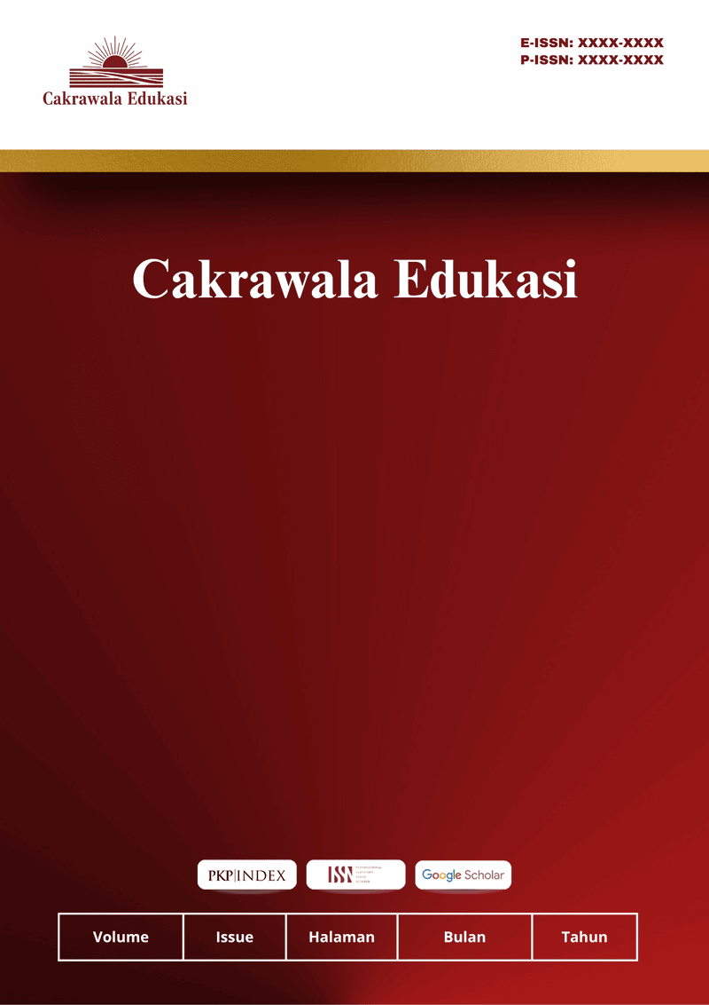
Cakrawala Edukasi
Vol 1 No 1 July 2026
ISSN: XXXX-XXXX (Print) ISSN: XXXX-XXXX (Electronic)
Open Access: https://cakrawalaedukasi.org/cakraedu/index

The Influence of School Administrative Staff Competence on the Performance of Education Personnel at SMA Mandala

Rani Amelia^{1*}, Aprilia Agustin², Rachel Aulis wijaya³, Billah Rahmatilah⁴, Rallyta Avriani⁵.
¹Universitas Muhammadiyah Bogor Raya
email: academicfive8@gmail.com

Article Info :  Received:  DDMMYY  Revised:  DDMMYY  Accepted:  DDMMYY | ABSTRACT (10 PT)
This study aims to clarify the impact of school administrative staff competency on teaching staff performance at Mandala High School. A quantitative approach using a survey method was used. This study involved 20 teaching staff members, selected using a complete census. Data collection was conducted by distributing valid and reliable questionnaires. Data were analyzed descriptively and inferentially to clarify the relationship between school administrative staff competency and teaching staff performance. The results showed that school administrative staff competency has a significant positive impact on teaching staff performance. Higher school administrative staff competency is associated with improved performance in supporting task implementation, service delivery, and effective education management by teaching staff at Mandala High School.

Keywords : competence of school administrative staff, performance of education personnel, educational administration, SMA Mandala.
©2022 Authors.. This work is licensed under a Creative Commons Attribution-Non Commercial 4.0 International License.
(https://creativecommons.org/licenses/by-nc/4.0/)
INTRODUCTION
Education is a crucial factor in improving the quality of human resources, therefore, its implementation must be optimally supported by all school components. In addition to teaching staff, school administrative staff play a strategic role in supporting the smooth running of education through administrative management, services, documentation, and the provision of information needed by all school members. In accordance with Minister of National Education Regulation No. 24 of 2008, school administrative staff are required to possess personal, social, technical, and managerial competencies to carry out their duties professionally. These competencies are the primary foundation for providing effective and efficient administrative services, thereby supporting the achievement of educational goals in schools.
The competence of school administrative staff is believed to be closely related to the performance of educational staff. The higher the competence, the better the educational staff's ability to carry out tasks, provide services, complete work on time, and build effective collaboration within the school environment. Previous research has shown that educational staff competence has a positive and significant impact on educational staff performance, where competence, encompassing knowledge, skills, and professional attitudes, can improve the quality of the implementation of tasks and responsibilities. Furthermore, competent administrative staff also contribute to creating an organized administrative system that supports the effectiveness of all educational staff.
As an educational institution, Mandala High School requires competent school administrative staff to support improved educational staff performance. However, various obstacles remain in its implementation, such as differences in competency levels, suboptimal administrative service effectiveness, and inadequate coordination in completing administrative tasks. These conditions have the potential to impact the performance of educational staff in carrying out their duties and functions at the school. Therefore, research into the influence of school administrative staff competency on educational staff performance at Mandala High School is crucial to determine the extent to which administrative staff competency contributes to improved educational staff performance. The results of this study are expected to serve as a basis for developing the quality of human resources within the school environment.

RESEARCH METHODS
This study used a quantitative approach with a survey method. The study was conducted at Mandala High School with a population of 20 educational staff. Due to the relatively small population, this study used a saturated sampling technique (total sampling), so that all members of the population were used as research samples. Data were collected through the distribution of questionnaires compiled based on indicators of school administrative staff competency as the independent variable (X) and educational staff performance as the dependent variable (Y). The research instrument has been tested for validity and reliability before use. The data obtained were analyzed using descriptive statistics and inferential statistics through analysis prerequisite tests, simple linear regression analysis, t-tests, and coefficients of determination with the help of the IBM SPSS Statistics application to determine the magnitude of the influence of school administrative staff competency on educational staff performance at Mandala High School.

RESULTS AND DISCUSSION (Capital, bold , Times new romance 11 pt)
- Research Results
Based on the research findings on the influence of school administrative staff competency on the performance of educational staff at Mandala High School, the following results were obtained.
- School Administrative Staff Competency
The descriptive analysis results indicate that the competency of school administrative staff is in the good category. This indicates that the majority of administrative staff possess adequate skills in carrying out school administrative tasks in accordance with their main duties and functions. These competencies include personality, social, technical, and managerial competencies. Administrative staff are able to work professionally, have responsibility for their work, are able to communicate well with all school members, and possess technical skills in managing school administration. These conditions indicate that administrative staff have met most of the competency standards as stipulated in Minister of National Education Regulation Number 24 of 2008.
- Educational Staff Performance
Based on the data processing results, it was found that the performance of educational staff at Mandala High School is also in the good category. This is evident in the ability of educational staff to complete their work according to assigned tasks, possess a high level of discipline, demonstrate responsibility for their work, collaborate effectively with colleagues, and provide optimal administrative services to teachers, students, and the school community. This strong performance demonstrates that educational staff have carried out their work in accordance with educational administration service standards.
- The Effect of Competence on Educational Staff Performance
The results of a simple linear regression analysis indicate that the competence of school administrative staff has a positive and significant effect on the performance of educational staff at Mandala High School. The results of the hypothesis test showed a significance value less than 0.05, thus accepting the research hypothesis. Therefore, it can be concluded that the higher the competence of school administrative staff, the higher the educational staff's performance in carrying out their duties. Conversely, if the competence of administrative staff is low, educational staff performance tends to decline.

- Discussion
- The Influence of Personality Competence on Education Personnel Performance
Personality competency is a skill related to character, integrity, responsibility, discipline, work ethic, honesty, and commitment in carrying out tasks. Based on research results, the personality competency possessed by school administrative staff has a positive influence on improving education staff performance. This occurs because administrative staff with good personalities work in a disciplined and responsible manner, and are able to maintain professionalism in carrying out their duties.
The disciplined attitude of administrative staff will impact the punctuality in completing administrative work, ensuring all school activities can run according to schedule. Furthermore, a strong sense of responsibility ensures that administrative staff do not procrastinate, maintain the confidentiality of school documents, and always strive to provide the best service to all school members. These conditions directly create a conducive work environment, enabling education staff to work more effectively.
- The Influence of Social Competence on Education Personnel Performance
Social competency relates to the ability of administrative staff to communicate, collaborate, respect others, provide service, and build harmonious working relationships. Research results show that strong social competence can improve the performance of educational staff by creating more effective work coordination.
Good communication between administrative staff and the principal, teachers, education staff, students, and parents will expedite the delivery of information and minimize administrative errors. Good cooperation between employees also results in faster work completion, resulting in more effective administrative services. A harmonious work environment will increase the motivation of all educational staff, thereby increasing work productivity. These results align with research by Susanti Novita Sari et al., which states that good cooperation between staff is a supporting factor in improving the quality of school administrative services.
- The Effect of Technical Competence on Educational Staff Performance
Technical competence is the ability of administrative staff to carry out administrative work professionally. This competence includes the ability to operate computers, manage correspondence, archive documents, manage student data, and administer school documents.

CONCLUSION
Based on the results of research regarding the influence of the competence of school administration staff on the performance of education staff at Mandala High School, it can be concluded that the competency of school administration staff has a positive and significant influence on the performance of education staff. The higher the competence of school administrative staff, which includes personality competence, social competence, technical competence and managerial competence, the better the performance of educational staff in carrying out their duties and responsibilities. These competencies are able to improve the quality of administrative services, facilitate coordination between employees, speed up work completion, and create an effective and conducive work environment for all school members. This finding is in line with previous research which shows that competence is an important factor that influences improving the performance of educational staff.
Apart from that, the research results show that the school administration staff at Mandala High School have competence in the good category so they are able to provide support for the smooth implementation of educational administration. The performance of educational staff is also in the good category, which is demonstrated through responsibility, quality of work, quantity of work, discipline, and ability to work together in carrying out tasks. However, competency improvement still needs to be carried out continuously through education and training, workshops, technical guidance, mastery of information technology, and regular performance evaluations. It is hoped that these efforts can increase the professionalism of school administration staff so that it will have an impact on improving the performance of education staff and the quality of education implementation at Mandala High School as a whole.
Increasing students' interest in reading amidst the onslaught of digital technology is a complex but very important challenge for the future of the younger generation. Rapid technological developments have changed students' information and entertainment consumption patterns, so that traditional reading interest has declined. However, technology can also be used as an effective literacy tool if used wisely and purposefully.

REFERENCES

Journal with DOI :
Imron, I., Purwanto, P., & Rohmadi, Y. (2021). Managerial competence of *madrasah* principals in developing the performance of teaching and educational staff. Jurnal Ilmiah Ekonomi Islam, 7(1), 350–359. https://doi.org/10.29040/jiei.v7i1.2228

Journal without DOI :
Rio, A., Alamsah, M., & Safitri, A. (2020). The influence of educational staff competence on the performance of educational staff at SMK Negeri 4 Kendari. Jurnal Pendidikan dan Pengajaran (JPP), 1(2), 46–58.
Rahmawati, S., Mujiati, M., & Rahmawati, R.M. (2021). Competence of administrative staff in improving the quality of educational administration. Jurnal Pendidikan dan Pengajaran (JPP), 2(2), 90–102.
Sari, S.N., Wahyudi, D., & Tartiyoso, S. (2020). School administrative staff competence regarding school services at SMA Negeri 1 Padang Tualang, Langkat Regency. Jurnal Serunai Administrasi Pendidikan, 9(2), 56–62.
Zakhiroh, R. (2013). The influence of school administrative staff performance on the quality of non-academic administrative services. Didaktika, 19(2), 59–73.

